EX NO:18 FOOD ORDERING SYSTEM

USE CASE DIAGRAM: 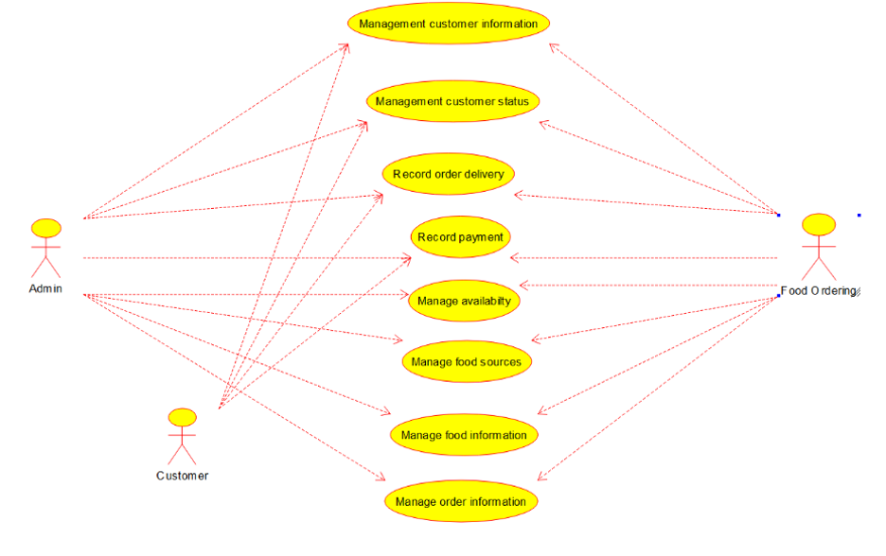CLASS DIAGRAM: 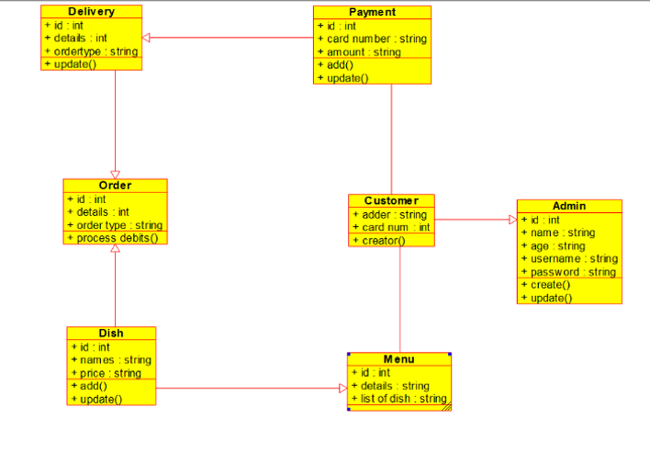

ACTIVITY DIAGRAM:



SEQUENCE DIAGRAM: 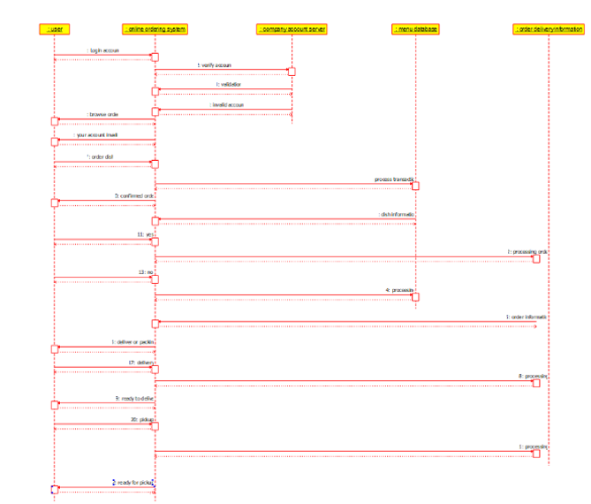

COLLABRATION DIAGRAM: 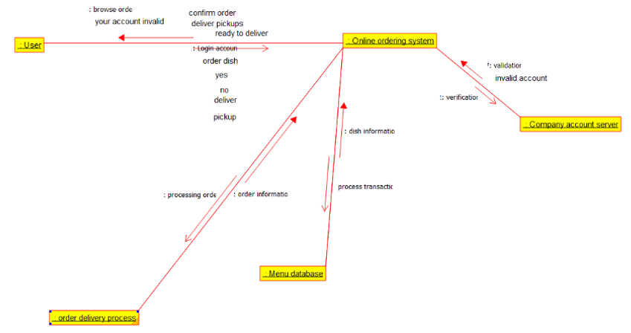

COMPONENT DIAGRAM: 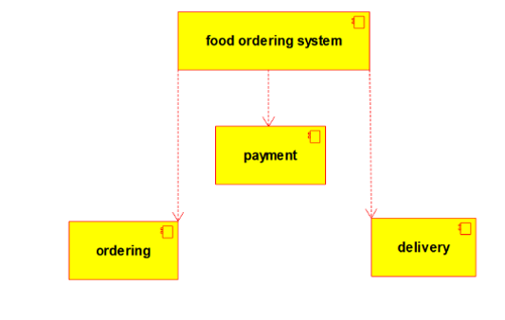

DEPLOYMENT DIAGRAM:

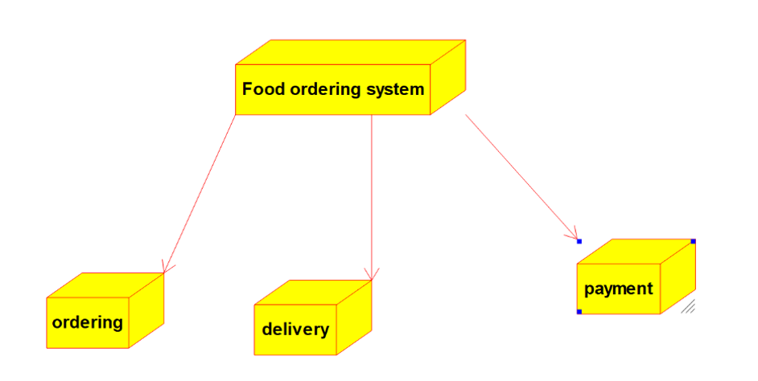

PROGRAM: /**

* Class Admin

*/

public class Admin {

//

// Fields

//

public int id;

public String name;

public String age;

public String username;

public String password;

//

// Constructors

//

public Admin () { };

//

// Methods

//

//

// Accessor methods

//

/**

* Set the value of id

* @param newVar the new value of id

*/

public void setId (int newVar) {

id = newVar;

}

/**

* Get the value of id

* @return the value of id

*/

public int getId () {

return id;

}

/**

* Set the value of name

* @param newVar the new value of name

*/

public void setName (String newVar) {

name = newVar;

}

/**

* Get the value of name

* @return the value of name

*/

public String getName () {

return name;

}

/**

* Set the value of age

* @param newVar the new value of age

*/

public void setAge (String newVar) {

age = newVar;

}

/**

* Get the value of age

* @return the value of age

*/

public String getAge () {

return age;

}

/**

* Set the value of username

* @param newVar the new value of username

*/

public void setUsername (String newVar) {

username = newVar;

}

/**

* Get the value of username

* @return the value of username

*/

public String getUsername () {

return username;

}

/**

* Set the value of password

* @param newVar the new value of password

*/

public void setPassword (String newVar) {

password = newVar;

}

/**

* Get the value of password

* @return the value of password

*/

public String getPassword () {

return password;

}

//

// Other methods

//

/**

*/

public void create()

{

}

/**

*/

public void update()

{

}

}

import java.util.*;

/**

* Class Customer

*/

public class Customer extends Admin {

//

// Fields

//

public String adder;

public int card_num;

//

// Constructors

//

public Customer () { };

//

// Methods

//

//

// Accessor methods

//

/**

* Set the value of adder

* @param newVar the new value of adder

*/

public void setAdder (String newVar) {

adder = newVar;

}

/**

* Get the value of adder

* @return the value of adder

*/

public String getAdder () {

return adder;

}

/**

* Set the value of card_num

* @param newVar the new value of card_num

*/

public void setCard_num (int newVar) {

card_num = newVar;

}

/**

* Get the value of card_num

* @return the value of card_num

*/

public int getCard_num () {

return card_num;

}

//

// Other methods

//

/**

*/

public void creator()

{

}

}

/**

* Class Delivery

*/

public class Delivery extends Order {

//

// Fields

//

public int id;

public int details;

public String ordertype;

//

// Constructors

//

public Delivery () { };

//

// Methods

//

//

// Accessor methods

//

/**

* Set the value of id

* @param newVar the new value of id

*/

public void setId (int newVar) {

id = newVar;

}

/**

* Get the value of id

* @return the value of id

*/

public int getId () {

return id;

}

/**

* Set the value of details

* @param newVar the new value of details

*/

public void setDetails (int newVar) {

details = newVar;

}

/**

* Get the value of details

* @return the value of details

*/

public int getDetails () {

return details;

}

/**

* Set the value of ordertype

* @param newVar the new value of ordertype

*/

public void setOrdertype (String newVar) {

ordertype = newVar;

}

/**

* Get the value of ordertype

* @return the value of ordertype

*/

public String getOrdertype () {

return ordertype;

}

//

// Other methods

//

/**

*/

public void update()

{

}

}

/**

* Class Dish

*/

public class Dish extends Order, Menu {

//

// Fields

//

// Accessor methods

//

/**

* Set the value of id

* @param newVar the new value of id

*/

public void setId (int newVar) {

id = newVar;

}

/**

* Get the value of id

* @return the value of id

*/

public int getId () {

return id;

}

/**

* Set the value of details

* @param newVar the new value of details

*/

public void setDetails (String newVar) {

details = newVar;

}

/**

* Get the value of details

* @return the value of details

*/

public String getDetails () {

return details;

}

/**

* Set the value of list_of_dish

* @param newVar the new value of list_of_dish

*/

public void setList_of_dish (String newVar) {

list_of_dish = newVar;

}

/**

* Get the value of list_of_dish

* @return the value of list_of_dish

*/

public String getList_of_dish () {

return list_of_dish;

}

//

// Other methods

//

}

/**

* Class Order

*/

public class Order {

//

// Fields

//

public int id;

public int details;

public String order_type;

//

// Constructors

//

public Order () { };

//

// Methods

//

//

// Accessor methods

//

/**

* Set the value of id

* @param newVar the new value of id

*/

public void setId (int newVar) {

id = newVar;

}

/**

* Get the value of id

* @return the value of id

*/

public int getId () {

return id;

}

/**

* Set the value of details

*/

public void setDetails (int newVar) {

details = newVar;

}

/**

* Get the value of details

* @return the value of details

*/

public int getDetails () {

return details;

}

/**

* Set the value of order_type

* @param newVar the new value of order_type

*/

public void setOrder_type (String newVar) {

order_type = newVar;

}

/**

* Get the value of order_type

* @return the value of order_type

*/

public String getOrder_type () {

return order_type;

}

//

// Other methods

//

/**

*/

public void process_debits()

{

}

}

import java.util.*;

/**

* Class Payment

*/

public class Payment extends Delivery {

//

// Fields

//

public int id;

public String card_number;

public String amount;

//

// Constructors

//

public Payment () { };

//

// Methods

//

//

// Accessor methods

//

/**

* Set the value of id

* @param newVar the new value of id

*/

public void setId (int newVar) {

id = newVar;

}

/**

* Get the value of id

* @return the value of id

*/

public int getId () {

return id;

}

/**

* Set the value of card_number

* @param newVar the new value of card_number

*/

public void setCard_number (String newVar) {

card_number = newVar;

}

/**

* Get the value of card_number

* @return the value of card_number

*/

public String getCard_number () {

return card_number;

}

/**

* Set the value of amount

* @param newVar the new value of amount

*/

public void setAmount (String newVar) {

amount = newVar;

}

/**

* Get the value of amount

* @return the value of amount

*/

public String getAmount () {

return amount;

}

//

// Other methods

//

/**

*/

public void add()

{

}

/**

*/

public void update()

{

}

}